MEDICARE
Data Profiling:
- Departments table- head_doctor_id is null
SELECT * from Departments where head_doctor_id is null ;

- Doctors - gender is in different formats
SELECT DISTINCT gender, COUNT(*)
from Doctors
Group by gender;

- Doctors - department_id is blank
SELECT * FROM Doctors where department_id IS NULL;

- Doctors - email is blank
SELECT * FROM Doctors where email IS NULL;

- Check email format
SELECT * FROM Doctors where email NOT REGEXP '^[A-Za-z0-9_%.-]+@[A-Za-z0-9-_.]+\\.[A-Za-z]{2,}$';

- Patients - Traling and leading spaces in first name
SELECT * from Patients where first_name <> ltrim(first_name);

- Patients - gender in different formats
SELECT gender, count(*)
FROM Patients
group by gender;

- Patient - Check for email blanks
SELECT * FROM Patients where email is null;

- To check the email format
SELECT * from Patients where email not regexp '^[A-Za-z0-9._%-]+@[A-Za-z0-9.-]+\\.[a-zA-Z]{2,}';
OR
SELECT * from Patients where email NOT like '%@%.%'; # this is another method to find invalid email, % includes any character

- Admissions - check for blanks in department_id
SELECT * from Admissions where department_id is null;

- Admissions - check for blanks in discharge_date
SELECT * from Admissions where discharge_date is null;

- Treatments - check for blanks in Admission_id
SELECT * FROM Treatments where Admission_id is null;

- Insurance - check for blanks in insurance_provider
SELECT * FROM Insurance where insurance_provider is null;

- Employee gender different formats
SELECT gender, count(*)
from Employee
group by gender;

- Employees - blanks in department_id
SELECT * FROM Employees where department_id is null;

- Billing - blanks in admission_id
SELECT * FROM Billing where admission_id is null;

- Employees - blanks in appointment_id
SELECT * FROM Billing where appointment_id is null;

Data Cleaning:
- Update the changed male and female column in the tables – Doctors
UPDATE Doctors
SET gender=
CASE
WHEN LOWER(TRIM(gender)) IN ('male','m')
THEN 'Male'
WHEN LOWER(TRIM(gender)) IN ('female','f')
THEN 'Female'
ELSE gender
END;

- Doctors - Cleaning the emails which are in wrong format
update Doctors
SET email=
CASE
WHEN email LIKE '%gmail.com' AND email NOT LIKE '%@%'
THEN REPLACE(email,'gmail.com','@gmail.com')
WHEN email LIKE '%@gmail'
THEN REPLACE(email,'@gmail','@gmail.com') # THEN CONCAT(email,'.com')
WHEN email LIKE '%@@gmail.com'
THEN REPLACE(email,'@@gmail.com','@gmail.com')
ELSE email
END
WHERE email not like '%@%.%' or
email like '%@@%.%';

- Patients - Trim the first_name column
UPDATE Patients
SET first_name=ltrim(first_name)
WHERE first_name <> LTRIM(first_name);

- Patients - gender in different format
update Patients
set gender =
CASE
WHEN lower(trim(gender)) in ('m','male')
THEN 'Male'
WHEN lower(trim(gender)) in ('f','female')
THEN 'Female'
ELSE gender
END;

- Patients – Cleaning the email format
UPDATE Patients
set email=
CASE
WHEN email LIKE '%gmail.com' AND email not like '%@%'
THEN REPLACE(email,'gmail.com','@gmail.com')
WHEN email like '%gmail'
then concat(email,'.com')
else email
end
where email not like '%@%.%';

- Employee - gender in different format
UPDATE Employees
set gender =
CASE
when lower(trim(gender)) in ('male','m')
then 'Male'
when lower(trim(gender)) in ('female','f')
then 'Female'
else gender
end;

Data Analysis:
1. List the unique hospital names
SELECT DISTINCT hospital_name
FROM Hospitals;
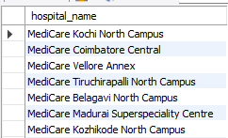

2. How many doctors have more than 10 years of experience?
SELECT COUNT(*) AS Experience_more_than_10_years
FROM Doctors
WHERE experience_years > 10;


3. What is the lowest consultation fee?
SELECT MIN(consultation_fee)
FROM Doctors;


4. What is the highest hospital bed capacity?
SELECT MAX(bed_capacity)
FROM Hospitals;


5. How many doctors are there in each specialization?
SELECT COUNT(*), specialization
FROM Doctors
GROUP BY specialization;
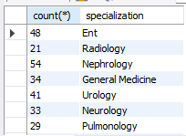

6. How many beds does each hospital have?
SELECT SUM(bed_capacity) AS B_cp, hospital_name
FROM Hospitals
GROUP BY hospital_name
HAVING B_cp > 300;
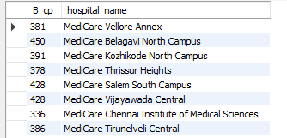

7. Show only specializations that have more than 20 doctors.
SELECT specialization, COUNT(doctor_id) AS d_id
FROM Doctors
GROUP BY specialization
HAVING d_id > 20;
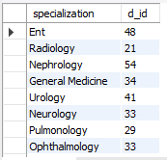

8. Show the top 5 specializations based on the number of doctors.
SELECT specialization, COUNT(doctor_id) AS top_5
FROM Doctors
GROUP BY specialization
ORDER BY top_5 DESC
LIMIT 5;
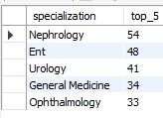

9. Give me each department along with the hospital it belongs to.
SELECT Departments.department_name, Hospitals.hospital_name
FROM Departments
INNER JOIN Hospitals
ON Departments.hospital_id = Hospitals.hospital_id;
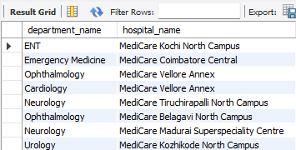

10. How many doctors are associated with each hospital?
SELECT COUNT(Doctors.doctor_id), Hospitals.hospital_id, Hospitals.hospital_name
FROM Doctors
INNER JOIN Hospitals
ON Doctors.hospital_id = Hospitals.hospital_id
GROUP BY Doctors.hospital_id;
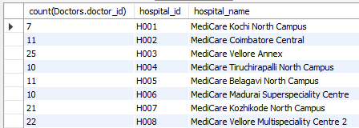

11. Show the departments along with their respective hospitals.
SELECT Hospitals.hospital_name, Departments.department_name
FROM Hospitals
LEFT JOIN Departments
ON Hospitals.hospital_id = Departments.hospital_id;
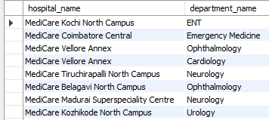

12. How many doctors does each hospital have?
SELECT Hospitals.hospital_name, COUNT(Doctors.doctor_id)
FROM Hospitals
LEFT JOIN Doctors
ON Hospitals.hospital_id = Doctors.hospital_id
GROUP BY Hospitals.hospital_id;
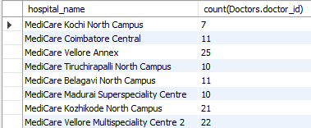

13. How many hospitals have more than 20 doctors?
SELECT Hospitals.hospital_name, COUNT(Doctors.doctor_id)
FROM Hospitals
LEFT JOIN Doctors
ON Hospitals.hospital_id = Doctors.hospital_id
GROUP BY Hospitals.hospital_id
HAVING COUNT(Doctors.doctor_id) > 20;
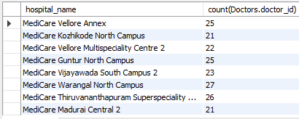

14. Which specialization has the highest number of doctors?
SELECT specialization, COUNT(doctor_id) AS m
FROM Doctors
GROUP BY specialization
ORDER BY m DESC
LIMIT 5;
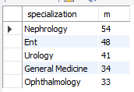

15. What is the average consultation fee by specialization?
SELECT specialization, AVG(consultation_fee) AS m
FROM Doctors
GROUP BY specialization;
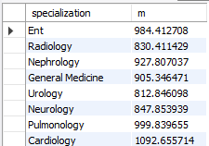

16. How many appointments does each doctor have?
SELECT doctor_id, COUNT(appointment_id)
FROM Appointments
GROUP BY doctor_id;
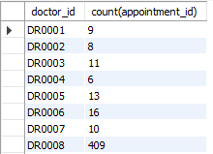

17. Rank the consultation fees from highest to lowest.
SELECT Doctors.first_name, Doctors.consultation_fee, specialization,
ROW_NUMBER() OVER (
ORDER BY Doctors.consultation_fee DESC
) AS rnk
FROM Doctors;
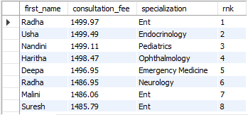

18. Rank the consultation fees from highest to lowest based on specialization.
SELECT Doctors.first_name, Doctors.consultation_fee, specialization,
ROW_NUMBER() OVER (
PARTITION BY specialization
ORDER BY Doctors.consultation_fee DESC
) AS rnk
FROM Doctors;
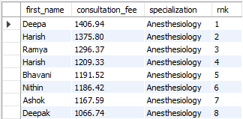

19. Rank the consultation fees from highest to lowest based on specialization, using the same rank for the same fees.
SELECT Doctors.first_name, Doctors.consultation_fee, specialization,
RANK() OVER (
PARTITION BY specialization
ORDER BY Doctors.consultation_fee DESC
) AS rnk
FROM Doctors;
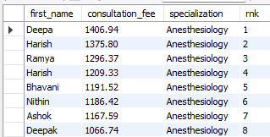

20. Display the previous consultation fee.
SELECT Doctors.first_name, Doctors.consultation_fee, specialization,
LAG(Doctors.consultation_fee) OVER (
ORDER BY Doctors.consultation_fee DESC
) AS rnk
FROM Doctors;
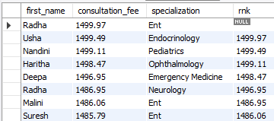

21. Display the consultation fee after the current row.
SELECT Doctors.first_name, Doctors.consultation_fee, specialization,
LEAD(Doctors.consultation_fee) OVER (
ORDER BY Doctors.consultation_fee DESC
) AS rnk
FROM Doctors;
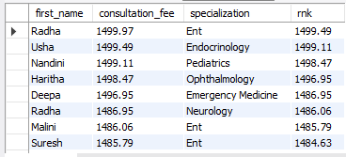

22. Rank the data based on consultation fee by department.
SELECT Departments.department_name, Doctors.first_name,
Doctors.consultation_fee,
ROW_NUMBER() OVER (
PARTITION BY Departments.department_name
ORDER BY Doctors.consultation_fee DESC
) AS rnk
FROM Departments
INNER JOIN Doctors
ON Doctors.hospital_id = Departments.hospital_id;
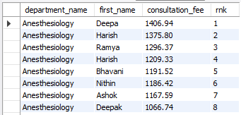

23. Rank the data based on consultation fee.
SELECT Departments.department_name, Doctors.first_name,
Doctors.consultation_fee,
ROW_NUMBER() OVER (
ORDER BY Doctors.consultation_fee DESC
) AS rnk
FROM Departments
INNER JOIN Doctors
ON Doctors.hospital_id = Departments.hospital_id;
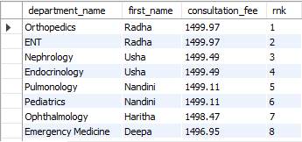

24. Show the top 5 hospitals based on the number of doctors.
SELECT Hospitals.hospital_name, COUNT(Doctors.doctor_id) AS c_d
FROM Hospitals
INNER JOIN Doctors
ON Hospitals.hospital_id = Doctors.hospital_id
GROUP BY Hospitals.hospital_name
ORDER BY c_d DESC
LIMIT 5;
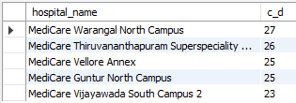

25. Display the hospital with the most doctors.
SELECT Hospitals.hospital_name, COUNT(Doctors.doctor_id) AS c_d
FROM Hospitals
INNER JOIN Doctors
ON Hospitals.hospital_id = Doctors.hospital_id
GROUP BY Hospitals.hospital_name
ORDER BY c_d DESC
LIMIT 1;
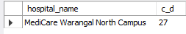

KPI :
- How many hospitals are there in Medicare?
SELECT COUNT(*) AS Total_no_of_Hospitals
FROM Hospitals;
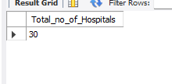
- How many departments are there in Medicare?
SELECT COUNT(*) AS Total_no_of_Department
FROM Departments;
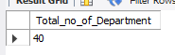

- How many doctors are there in Medicare?
SELECT COUNT(*) AS Total_no_of_Doctors
FROM Doctors;


- What is the total number of beds across all hospitals?
SELECT SUM(bed_capacity)
FROM Hospitals;
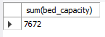

- What is the average consultation fee?
SELECT ROUND(AVG(consultation_fee), 2)
FROM Doctors;
